**Profile**

**News/Events**

**Assignments**

**Projects**

**Mark details**

**Attendance**

**Password reset**

**About**

**Sign In**

**Fee details**

D

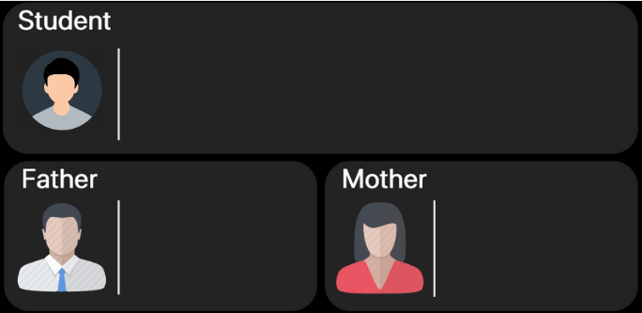

Name :

Ph :

Name :

Ph :

Name : Admission No. :

Ph : Course :

Year : ID : Blood grp. :



Edit

Hgdjsrirys

Name : Admission No. :

Ph : Course :

Year : ID : Blood grp. :

**Mother**

**Father**

**Student**

Save



Cancel



**Administrator**

**-1**

**Student**

**-**

Percentage

Marks obtained

1st year

Sem-1

Student

Administrator

2nd year

Sem-3

Sem-2

3rd year

Sem-5

Sem-4

4th year

Sem-6

Sem-8

Sem-7

Title

Assigned on

Submission on

Absent

Holidays

Permitted leave

Present